Exam 2 Part 2

Program 1 Pseudocode.

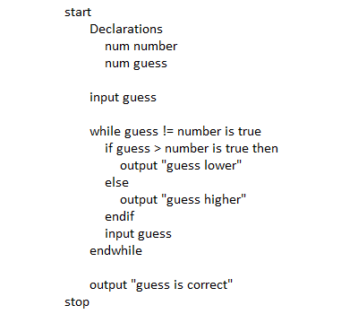

Program 1 Code.

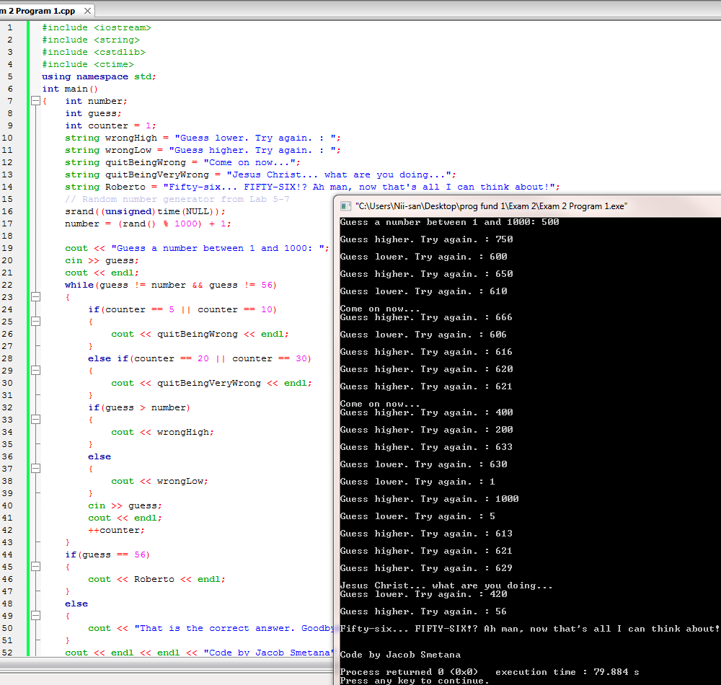

Program 2 Flowchart & Pseudocode.

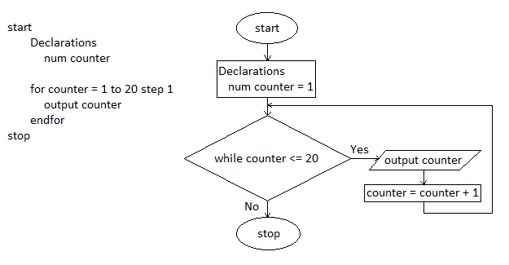

Program 2 Code.

